Assignment 4
Name :- Raghav Anil Bhise
PRN :- 22311792
Roll no. :- 391061
Title :- Build a Named Entity Recognition (NER) system for extracting entities from real-world text such as news articles or social media data. And measure its accuracy, precision, recall, and F1-score.
Objective
To build a Named Entity Recognition (NER) system that extracts important entities such as person names, locations, organizations, and dates from real-world text (news/social media). Also, to evaluate the system using Accuracy, Precision, Recall, and F1-score.
Tools & Technologies Used
- Python Programming Language
- Google Colab Environment
- spaCy NLP Library
- Pretrained Model: en_core_web_sm
Methodology
- Installed the spaCy natural language processing library and downloaded the pretrained English NER model.
- Created a small dataset consisting of multiple real-world sentences similar to news and social media text.
- Processed each sentence using the spaCy model to extract named entities.
- Manually defined the correct entities (ground truth labels) for each sentence.
- Compared the predicted entities with the true entities.
- Calculated evaluation metrics including Accuracy, Precision, Recall, and F1-score.
Input Text
- Apple launched a new iPhone in California in September 2023.
- Prime Minister Narendra Modi visited the United States last year.
- Google opened a new office in Bengaluru on Monday.
- Elon Musk is the CEO of Tesla and SpaceX.
- The FIFA World Cup was held in Qatar in 2022.
Code
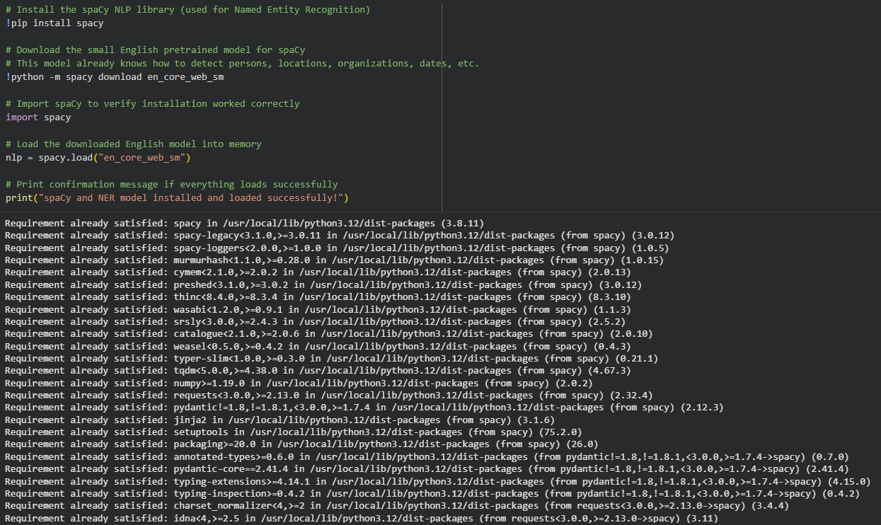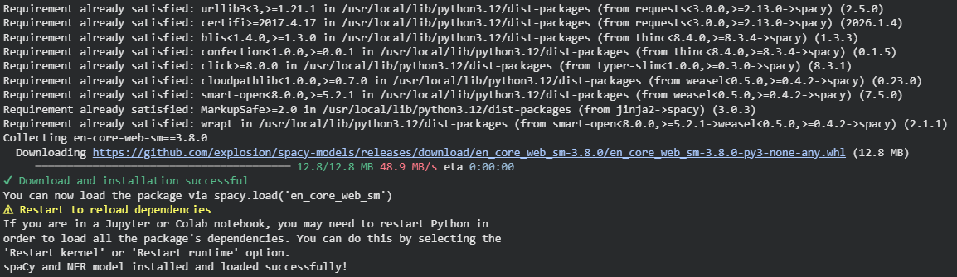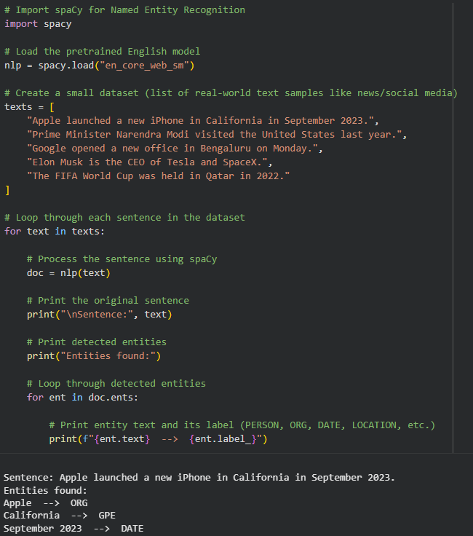
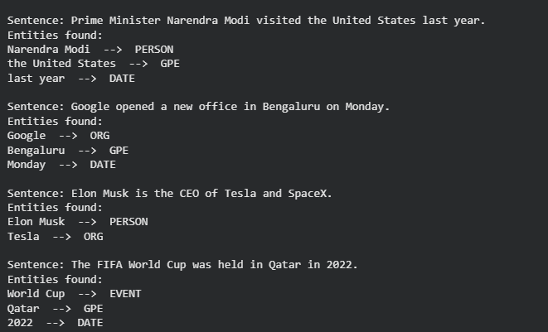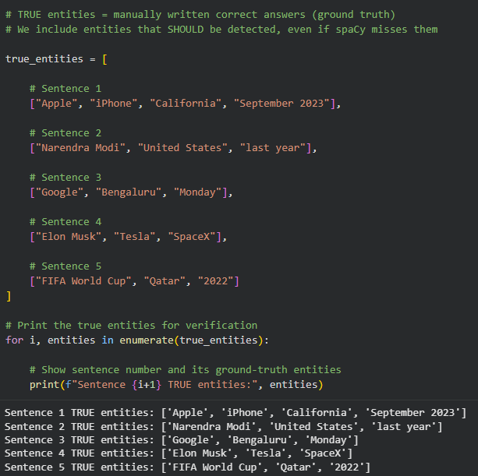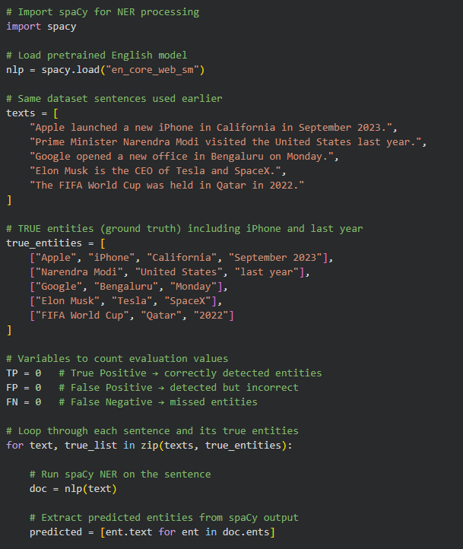
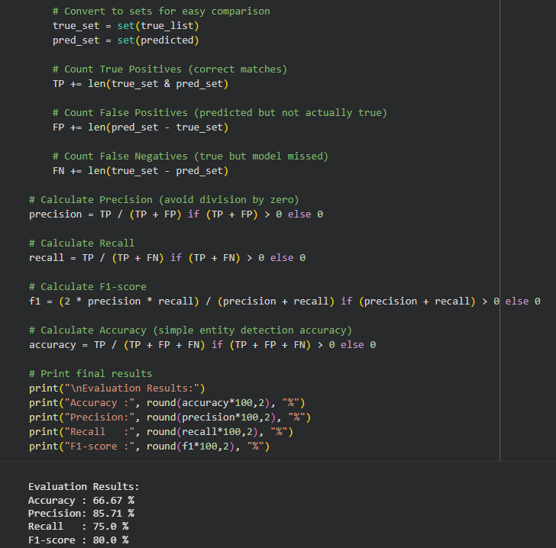
Output
The system successfully detected entities such as:
- Organizations → Apple, Google, Tesla, SpaceX
- Persons → Narendra Modi, Elon Musk
- Locations → California, United States, Bengaluru, Qatar
- Dates → September 2023, Monday, 2022
Some entities like iPhone (product name) and last year (relative date) were not always detected due to limitations of the pretrained lightweight model.
Performance Evaluation
The system performance was measured using:
- Accuracy → overall correct entity detection
- Precision → how many detected entities were correct
- Recall → how many actual entities were detected
- F1-score → balance between precision and recall
Conclusion
A Named Entity Recognition system was successfully implemented using the spaCy pretrained model. The system was able to extract most standard entities such as person names, locations, organizations, and dates from real-world text. However, some ambiguous expressions and product names were not detected, showing the limitations of lightweight pretrained models. Overall, the experiment demonstrates how NLP techniques can be used for automatic information extraction from textual data.

